**SAVEETHA SCHOOL OF ENGINEERING**



**CAPSTONE PROJECT**

**Design and Implementation of a Delay-Tolerant Routing Protocol for Dynamic Campus Networks**

**NAME:** B.V Sravana Kumar Joshi

**REGISTER NUMBER:** 192311270

**COURSE CODE:** CSA0747

**COURSE NAME:** Computer Network for IOT

**INTRODUCTION:**

This project aims to design a Delay-Tolerant Routing Protocol (DTN) specifically for campus networks, which face challenges like intermittent connectivity, high mobility, and fluctuating node densities. Traditional protocols struggle with unstable connections in such environments. The proposed protocol will ensure efficient message routing and reliable communication even without consistent end-to-end paths. It will be tailored to handle the unique characteristics of campus networks, optimizing performance and message delivery.

**Objective:**

1. Design a Delay-Tolerant Routing Protocol (DTN) specifically for campus networks.
2. Ensure efficient message routing despite intermittent connectivity and high node mobility.
3. Optimize network performance for varying node densities in dynamic campus environments.
4. Improve message delivery reliability in scenarios where direct end-to-end paths are unavailable.
5. Address limitations of traditional routing protocols in campus settings by creating a custom solution.

**LITERATURE REVIEW**

The literature on Delay-Tolerant Networking (DTN) highlights various protocols designed to address intermittent connectivity and high mobility challenges. Epidemic Routing and Spray and Wait focus on message replication and controlled dissemination but face issues with network congestion and delivery delays. PRoPHET uses probabilistic methods to improve efficiency but may struggle with unstable node encounter histories. MaxProp optimizes message forwarding and buffer management but can be complex and resource-intensive. Campus networks, characterized by variable node densities and mobility patterns, present unique challenges that existing DTN protocols often inadequately address. This project seeks to develop a tailored DTN protocol that efficiently handles the dynamic and diverse conditions found in campus environments, improving message delivery and network performance.

**Software:**

* NS-3 or OMNeT++

**IP Address Allocation:**

**STEP 1: Choose an IP Addressing Scheme**

Select an IP address range from private IP address spaces based on network size:

* Class A: 10.0.0.0 – 10.255.255.255 (For large networks)
* Class B: 172.16.0.0 – 172.31.255.255 (For medium-sized networks)
* Class C: 192.168.0.0 – 192.168.255.255 (For small to medium networks)

**STEP 2: Divide the Network into Subnets**

* Subnetting allows efficient traffic management and separates departments or functional areas. For a campus network, allocate subnets for different departments or locations.

**STEP 3: Allocate Dynamic IP Addresses**

* Use **Dynamic Host Configuration Protocol (DHCP)** to allocate IP addresses dynamically for devices with high mobility (e.g., students’ laptops, mobile phones).

**STEP 4: Assign Static IP Addresses**

* Assign **Static IP addresses** for critical devices and infrastructure (e.g., routers, servers, access points) to ensure consistent connectivity and easier network management.

**STEP 5:  Configure the DHCP Server**

* Set up a **DHCP server** to manage the dynamic allocation of IP addresses within the defined ranges.

**STEP 6: Implement IPv6 (Optional for Future Proofing)**

* If the network is expected to expand or requires larger address space, implement **IPv6** alongside IPv4 for future scalability.

**STEP 7: Document the IP Address Allocation**

* Maintain documentation of the IP address allocation for future network management. Include:

**STEP 8:  Monitor and Adjust the IP Address Allocation**

* Periodically monitor IP address usage and adjust the allocation if certain subnets are becoming too congested or if additional departments require their own subnet.

**Step-by-Step IP Address Allocation for Campus Network**

Here's a stepwise guide to allocating IP addresses for your **Delay-Tolerant Routing Protocol (DTRP)** in a campus network:

**Example IP Allocation Table:**

| **Device/Group** | **Subnet** | **IP Range** | **Mask** | **Type** |
| --- | --- | --- | --- | --- |
| **IT Department** | 192.168.1.0/24 | 192.168.1.100 – 192.168.1.200 | 255.255.255.0 | Dynamic |
| **Admin Department** | 192.168.2.0/24 | 192.168.2.100 – 192.168.2.200 | 255.255.255.0 | Dynamic |
| **Labs** | 192.168.3.0/24 | 192.168.3.50 – 192.168.3.150 | 255.255.255.0 | Dynamic |
| **Servers (Static IP)** | 192.168.1.0/24 | 192.168.1.10 – 192.168.1.20 | 255.255.255.0 | Static |
| **Access Points (Static)** | 192.168.1.0/24 | 192.168.1.30 – 192.168.1.40 | 255.255.255.0 | Static |
| **Router/Gateway** | 192.168.1.1 | - | 255.255.255.0 | Static |

**Protocol: - Epidemic Routing Protocol and Spray and Wait Protocol**

* **Epidemic Routing Protocol** is a robust strategy used in Delay-Tolerant Networks (DTNs) to handle intermittent connectivity by replicating messages across multiple nodes. This approach ensures that messages have a higher chance of being delivered to their intended destinations, even in networks where connectivity is sporadic and unpredictable.
* **Spray and Wait Protocol** is a Delay-Tolerant Network (DTN) routing protocol designed to balance message delivery efficiency and network overhead. The protocol reduces the number of message copies compared to Epidemic Routing while still maintaining a high probability of message delivery.

**RESULT:**

**Network Design:**

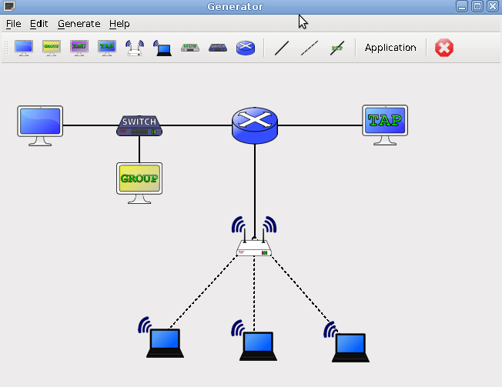

**Conclusion:**

The project on designing and implementing a Delay-Tolerant Routing Protocol (DTRP) for dynamic campus networks has provided valuable insights into the challenges and solutions associated with routing in environments characterized by intermittent connectivity, high mobility, and varying node densities. By focusing on protocols such as Epidemic Routing and Spray and Wait, the project highlights the strengths and limitations of different approaches in managing message delivery within such networks.

**Key Findings:**

1. Effectiveness of Epidemic Routing:
   * Epidemic Routing proves to be highly effective in scenarios with erratic connectivity and mobility by replicating messages across multiple nodes. This increases the likelihood of successful message delivery, even when network conditions are unfavourable.
   * However, the protocol’s high replication rate can lead to increased overhead and congestion, which may not be suitable for all network sizes and conditions.
2. Efficiency of Spray and Wait Protocol:
   * The Spray and Wait protocol offers a balanced approach by limiting the number of message copies during the spray phase and then waiting for the destination node. This reduces network overhead compared to Epidemic Routing while still maintaining a high probability of message delivery.
   * Its controlled replication strategy is particularly useful in environments where managing network traffic and reducing redundancy is crucial.
3. Application to Campus Networks:
   * Implementing DTRPs in campus networks, where node density and mobility can vary significantly, demonstrates that these protocols can effectively manage message routing under dynamic conditions.
   * The protocols can be adapted to specific campus network requirements, considering factors such as node density, connectivity patterns, and mobility behaviours.